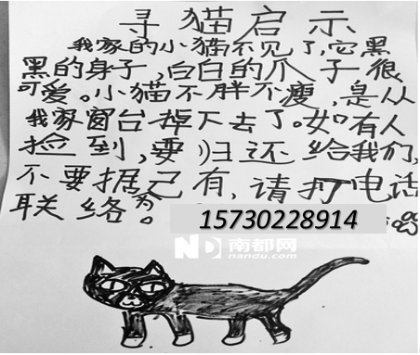

1. 你看到了什么？
2. Circle the body parts and adjectives that describe the cat’s appearance.
3.
- What is the purpose of this post?
- What happened to the cat?
- What does the cat look like?
- What is the purpose of the number there?

资料来源：
http://epaper.oeeee.com/N/html/2013-08/21/content_1918796.htm

